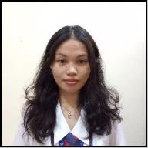
Personal Background

Name: Charlaine Mae Mari M. Ornopia
Program: Bachelor of Special Needs Education
Home Address: Sitio San Agustin, Poblacion, Kananga, Leyte
Birthday: November 30, 2003
Place of Birth: Kananga, Leyte
Civil Status: Single
Contact Number: 09606645596

Email address: charlainem.ornopia@gmail.com
Nationality: Filipino
Religion: Roman Catholic

Educational Background

Level | School | Year Graduated | Honors Received
Elementary | Kananga Central School | 2016 | With Honors
Junior High  School | Kananga National High School | 2020 | With Honors
Senior High  School | Valencia National High School  – Senior High School | 2022 | With Honors
College | Leyte Normal University | IP | IP

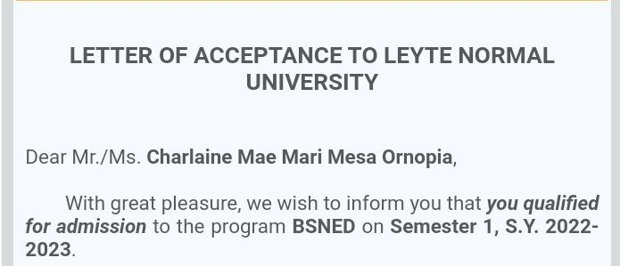
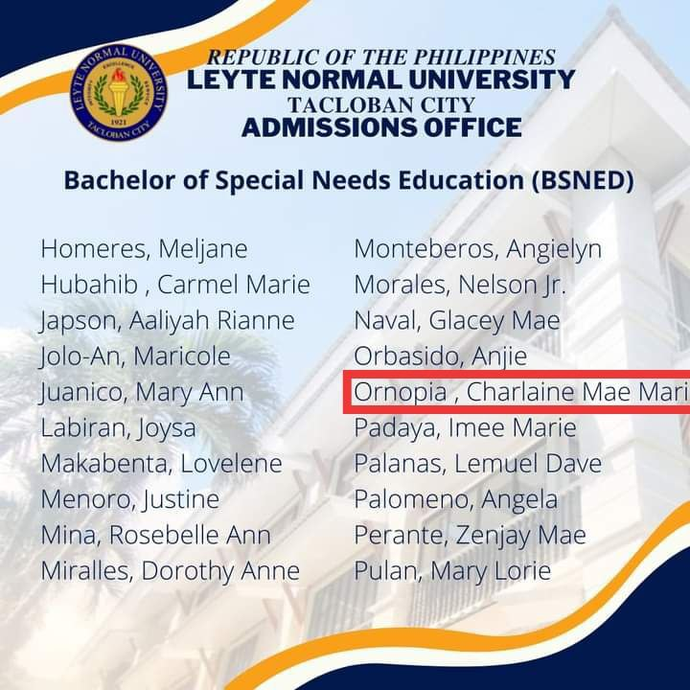
When I entered my first year of college, I had no idea what to expect. I was excited but also nervous at the same time because it would be my first time being away from my family. I applied for admission to Leyte Normal University—the only school where I sent my application. I asked my mother what program I should take, and she told me to put Bachelor of Physical Education as my first choice and Bachelor of Special Needs Education as my second choice. Unfortunately, I got so excited that I clicked the wrong box— instead of BPEd, it was BTLEd. And the funny thing is, I only realized it when the interviewer from BTLEd emailed me to confirm the interview schedule. To cut the story short, I qualified for both programs, BTLEd and BSNEd, but my mother told me to choose BSNEd. Of course, I was disappointed because I badly wanted to take BPEd, but maybe that mistake was a redirection. My expectations for college were very far from what it was actually like.
When classes started, I was not confident—everything was new to me. Even though classes were conducted online, I still felt the pressure because in my hometown, the internet connection was not stable, and almost every course required online sessions. Another challenge was the language barrier—they weren’t Bisaya. As a Bisaya girlie, it was hard, but thank God I had my mother. She became my translator, helping me communicate with my classmates and translating Waray words for me every time the instructor spoke in Waray. My challenges during the adjustment period were difficult—managing my time as a daughter and as a student. Others would say that online classes were easy since we were just at home, but it wasn’t easy for me, especially with the noisy neighbors. My confidence also almost hit rock bottom. There were times when I wanted to give up on college, but my parents kept motivating me. As months passed by, I finally settled in—I could join the conversations in the group chat and I already had friends.
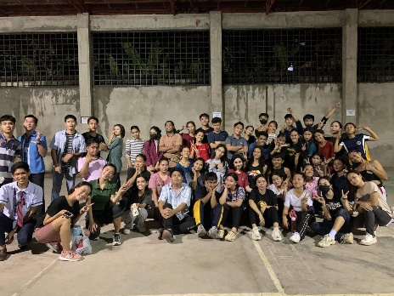
Then the Sportsfest came. I joined the cheerdance competition, and that’s where I met my classmates in college—Cristy and Carmel, and from the other section, Ethelbert and Zybel. We clicked immediately and became close friends; we were always together throughout the practice until competition day. Even though we didn’t win, I was happy that I made friends on my own—talking to them was the hard part.
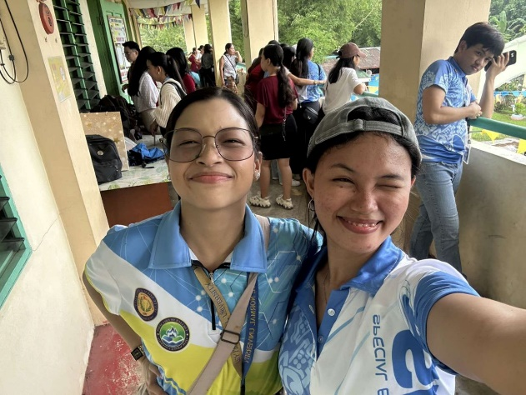
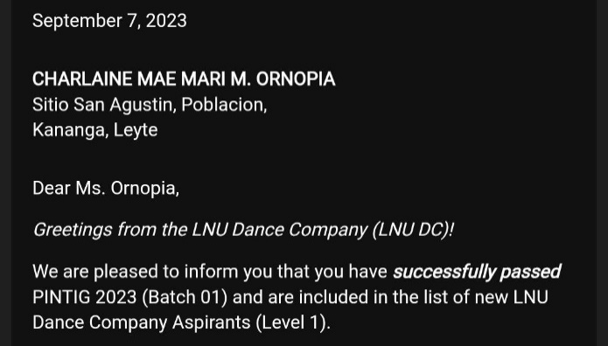
I was in my second year when I joined the LNU Dance Company. It felt like a dream come true—I watched their performance during the university’s foundation week and told myself that I would really join that group one day. Thankfully, I was one of the accepted auditionees, and my journey as a dancer had never been better. Balancing academics and dancing was quite hard, though. I was the classroom president while also serving as the second-year representative of the SpEL Organization. I would go to school at 8 in the morning and return home between 8 and 9 in the evening. I was exhausted—that’s for sure—but nevertheless, I loved dancing. And that’s where I met Ate Louie, also a BSNEd student. She was the first to welcome me to the studio and talked to me, making me feel included. I love her so much—she’s the sweetest ate I’ve ever met. Little did I know that joining the dance group would make me stronger—meeting new people by myself and auditioning alone were things my old self could never do without bringing my mother with me.
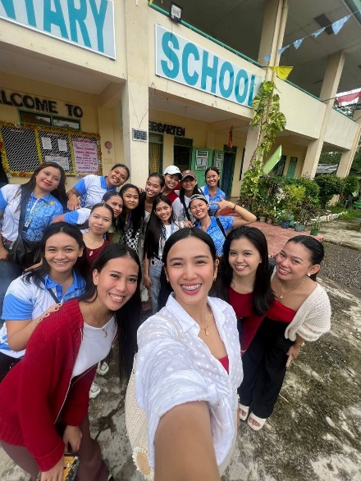
Third year was hell. To be honest, I can’t remember half of the school year because I was just clutching the entire semester trying to pass every course. I was like a leaf going with the flow wherever the wind took me. We then went to Caibaan Elementary School to give school supplies to the learners, and seeing their happy faces was enough motivation for me to pursue becoming an elementary teacher. However, the journey to that school was not easy—we had to walk almost 1 km because one of our classmates said it would be near once we got off the multicab; it was nowhere near.

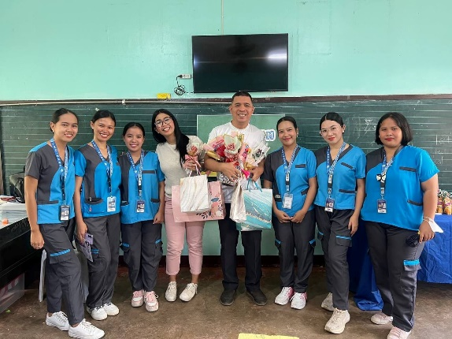
Sadly, in the second semester, I was enrolled in the second section due to issues with our clearance form. Then we also had our Field Study—I was assigned to the hearing-impaired class. Not gonna lie, the first day we were introduced to the learners almost made me tear up—not only because I remembered my deceased deaf cousin, but also because I remembered her love for teaching children despite her disabilities. I told myself that I would be the one to continue her dream. Even though we spent only a short time with them, I became attached and wanted to stay with them longer. But everything has to come to an end. The only connection I have with the learners I met during our Field Study is through Facebook. For me, it was a blessing in disguise. We had financial problems during that time, and thankfully, my schedule allowed me to stay home more and be with my family.
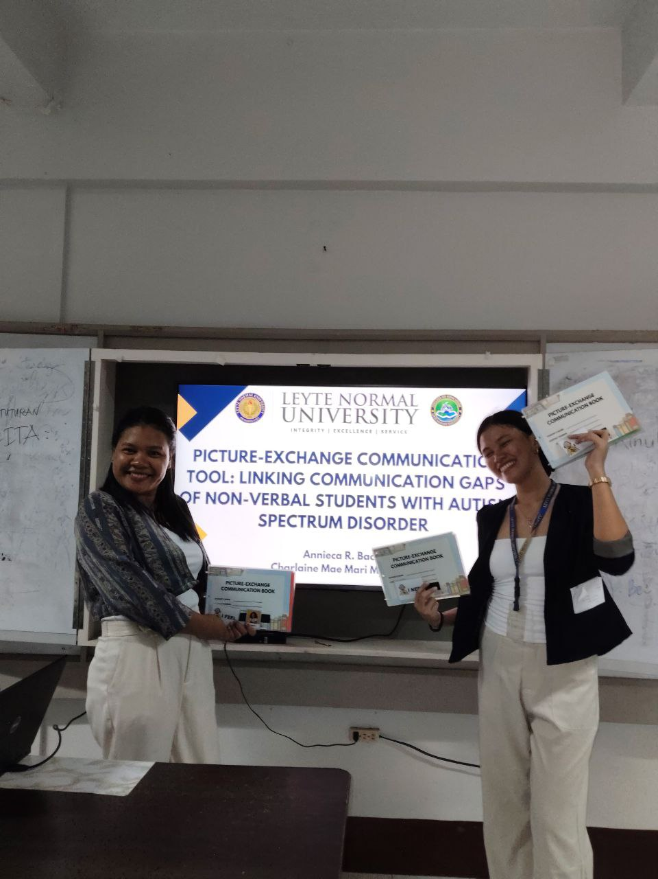
Fourth year is kinda chill. Mostly the courses we take are minors—it felt like a reward, except for the fact that I had to study for a Filipino course (I am not a fan of Filipino subjects). We were able to defend our research paper—the only thing that would’ve held us back from having a smooth internship if we didn’t defend it. I’m thankful for my partner because she didn’t give up on me—shoutout sa’yo, Ate Annieca.
My growth is really visible—from not being able to do things without my mother to doing everything on my own. The shy first-year student became confident and capable by fourth year. College really taught me to tough it out and never let my doubts control my emotions. Also, find good friends—and if you can’t, it’s also fine to be alone. My college journey taught me that success isn’t about being perfect—it’s about standing up every time you fall and believing you can become better. And of course, I would not have reached this level without my parents’ support. Thank you, mama and papa! Mo bawi ra ko sa inyo puhon!

